IRKUTSK STATE UNIVERSITY
FACULTY OF BIOLOGY AND SOIL STUDIES
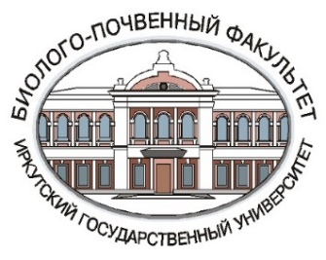


IVth All-Russian Scientific and Practical Conference with international participation
«DEVELOPMENT OF PHYSICO-CHEMICAL BIOLOGY, BIOTECHNOLOGY AND BIOINFORMATICS
AT THE PRESENT STAGE»
dedicated to the 45th Anniversary of the Department of Physical and Chemical Biology, Bioengineering and Bioinformatics, Irkutsk State University
October 25-27, 2023
Irkutsk

FIRST CIRCULAR
Dear colleagues,
You are cordially invited to take part in the IVth All-Russian Scientific and Practical Conference with international participation, devoted to the discussion of key problems of physical and chemical biology, biotechnology and bioinformatics. The Conference will include plenary and breakout sessions and a poster session. Speakers who attend in person will receive a personal certificate of attendance.
Non-resident participants of the Conference will be given the opportunity to make a report in a remote interactive mode using remote technologies (online broadcast of the event via a private link). There is a possibility of participation in absentia.

With the participation and support:
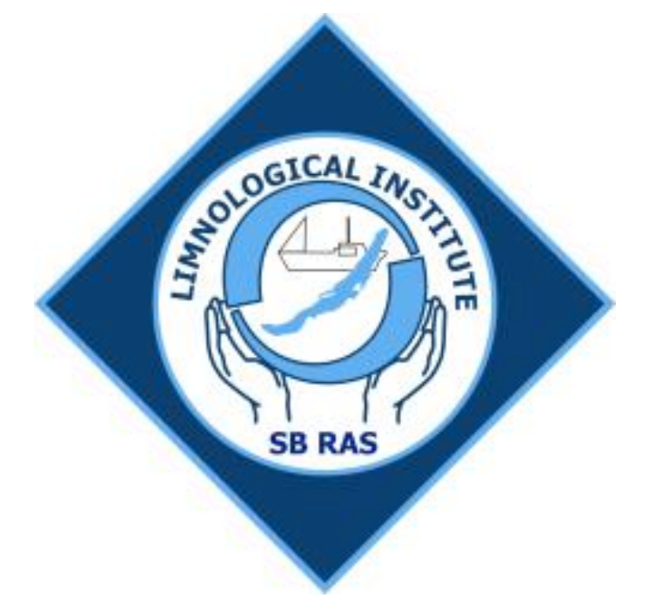 |  | 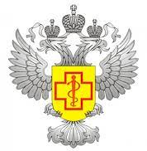 | 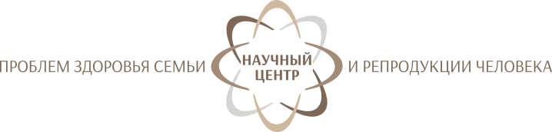
LIN SB RAS | SIPPB SB RAS | Antiplague Institute | SC FHHRP
The conference is dedicated to the consideration of the latest experimental technologies, bioinformatics methods and their application in practice. Special attention will be paid to new data on the formation of complex diagnostic platforms, the scientific basis of biotechnological production, research using modern high-performance technologies, DNA sequencing, mass spectrometry and other methods, as well as unique scientific equipment. The conference will present the latest research results in the field of mathematical description of biological systems in the relevant areas of bioinformatics, molecular and structural biology, biomedicine, pharmacology, biotechnology and ecology.
The goal of the Conference is to develop scientific potential, integrate science and practice, and support gifted youth.
The venue of the Conference is the Faculty of Biology and Soil Science, Irkutsk State University (5, Sukhe-Batora St., Irkutsk 664003, Russia).

Scientific issues to be discussed:
- Medical-biological problems and perspectives
- Biodiversity and systematics of organisms
- Ecology and rational nature management
- Theoretical and applied aspects of biotechnology

Programme Committee:

Chairman:
Schmidt A.F. – Dr. Sc. (Chemistry), Prof., Rector, Irkutsk State University (Irkutsk)
Deputy Chairman:
Salovarova V.P. – Dr. Sc. (Biology), Prof., Head of the Department of Physical and Chemical Biology, Bioengineering and Bioinformatics, Irkutsk State University (Irkutsk);
Members:
Balahonov S.V. - Dr. Sc. (Medical Sciences), Prof., Director, Irkutsk Antiplague Scientific Research Institute for Siberia and Far East (Irkutsk);
Voronin V.I. – Dr. Sc. (Biology), Prof., Director, Siberian Institute of Plant Physiology and Biochemistry SB RAS (Irkutsk);
Zlobin V.I. - Academician of RAS, Honored Scientist of the Russian Federation and the Republic of Buryatia, Dr. Sc. (Medical Sciences), Prof., N.F. Gamaleya National Center of Epidemiology and Microbiology (Moscow);
Kolesnikova L.I. – Academician of RAS, Honored Worker of Science of the Russian Federation, Dr. Sc. (Medical Sciences), Prof., Honored Worker of Science of the Russian Federation, Scientific Director, Scientific Сentre for Family Health and Human Reproduction Problems (Irkutsk);
Kolodkin A.N. - Ph.D in Systems Biology, Luxembourg Institute of Health (Luxembourg);
Klimenkov I.V. - Dr. Sc. (Biology), Prof., Irkutsk State University, Limnological Institute SB RAS (Irkutsk);
Kupchinsky A.B. – Cand. Sc. (Biology), Director, Baikal Museum of the Irkutsk Scientific Center SB RAS (Irkutsk);
Matveev A.N. – Dr. Sc. (Biology), Prof., Dean of the Faculty of Biology and Soil Science, Irkutsk State University (Irkutsk);
Ogarkov B.N. – Dr. Sc. (Biology), Prof., Head of the Department of Microbiology, Irkutsk State University (Irkutsk):
Ogarkov O.B. - Dr. Sc. (Medical Sciences), Head of the Department of Epidemiology and Microbiology, Scientific Сentre for Family Health and Human Reproduction Problems (Irkutsk)
Riсhter V.A. – Cand. Sc. (Biology), Head of the Laboratory of Biotechnology, Institute of Chemical Biology and Fundamental Medicine SB RAS (Novosibirsk);
Delgermaa Sovd – Cand. Sc. (Biology), Prof., Department of Biotechnology and Nutrition, Mongolian University of Science and Technology, Institute of Industrial Technology (Mongolia);
Timofeyev M.A. - Dr. Sc. (Biology), Prof., Director, Research Institute of Biology, Irkutsk State University (Irkutsk);
Troitsky A.V. - Dr. Sc. (Biology), Prof., Head of the Department of Evolutionary Biochemistry, A.N. Belozersky Institute Of Physico-Chemical Biology, Moscow State University (Moscow);
Sherbakov D.Yu. - Dr. Sc. (Biology), Prof., Irkutsk State University, Limnological Institute SB RAS (Irkutsk)

Organizing Committee:

Conference Secretariat:
Pristavka А.А. – Cand. Sc. (Biology), Department of Physical and Chemical Biology, Bioengineering and Bioinformatics, Irkutsk State University (Irkutsk).
Members:
Bukin Yu.S. - Cand. Sc. (Biology), Department of Physical and Chemical Biology, Bioengineering and Bioinformatics, Irkutsk State University, Limnological Institute SB RAS (Irkutsk)
Mikhailenko V.L. - Cand. Sc. (Chemistry), Department of Physical and Chemical Biology, Bioengineering and Bioinformatics, Irkutsk State University (Irkutsk)
Pavlichenko V.V.- Cand. Sc. (Biology), Department of Physical and Chemical Biology, Bioengineering and Bioinformatics, Irkutsk State University, Siberian Institute of Plant Physiology and Biochemistry SB RAS (Irkutsk);
Protopopova M.V.- Cand. Sc. (Biology), Department of Physical and Chemical Biology, Bioengineering and Bioinformatics, Irkutsk State University, Siberian Institute of Plant Physiology and Biochemistry SB RAS (Irkutsk).
Sapozhnikova Yu.P. - Cand. Sc. (Biology), Laboratory of Ichthyology, Limnological Institute SB RAS (Irkutsk)
Teterina G.A. – Department of Physical and Chemical Biology, Bioengineering and Bioinformatics, Irkutsk State University, Irkutsk Regional College of Culture (Irkutsk);
Yurinova G.V. - Cand. Sc. (Biology), Department of Physical and Chemical Biology, Bioengineering and Bioinformatics, Irkutsk State University (Irkutsk).

The official languages of the Conference: Russian and English.

Accepted reports will be published in the electronic abstract collection of the Conference with the assignment of the international index ISBN, LBC and indexing in RSCI. Materials will be published in the author's edition. The requirements for abstracts can be found on the event website - http://biosoil.isu.ru/ru/science/konfernzay.html
Authors have the opportunity to submit the materials of the report in the form of a separate article, which can be published in one of the journals - partners of the event, after review by the Programme Committee:
- Acta Biomedica Scientifica (Scopus) – https://www.actabiomedica.ru/jour
- Izvestiya Irkutskogo Gosudarstvennogo Universiteta. Seriya “Biologiya. Ecologiya” (In the list of the Higher Attestation Commission, VAK) – http://izvestiabio.isu.ru/en
- Limnology and Freshwater Biology (RSCI) – http://www.limnolfwbiol.com/index.php/LFWB
Registration and fee payment details

To attend the Conference, you need to fill out the online form at the following link: https://forms.gle/JKmBm43DbaJXCiX5A. (NB. You should also use the same form to submit abstracts and scanned documents for payment of the registration fee).
The amount of the registration fee ranges from 1500 to 3000 rubles, depending on the form of participation and the status of the event participant (http://biosoil.isu.ru/ru/science/konfernzay.html).

Important dates:

February 27, 2023 | Start of registration
April 15, 2023 | Distribution of the Second Circular
May 1, 2023 | Deadline for registration
June 1, 2023 | Deadline for submission of articles for the journals
July 1, 2023 | Selection of articles by the Programme Committee
August 1, 2023 | Deadline for submission of articles to the peer review journals
September 1, 2023 | Deadline for submission of abstracts and final confirmation of participation form  Deadline for fee payment
October 1, 2023 | Completion of peer review of articles by journal editors  Conclusion of contracts for the publication of articles in the journals
October 10, 2023 | Distribution of the Conference programme

Address of Organising Committee:

Faculty of Biology and Soil Science, Irkutsk State University
5, Sukhe-Batora St., Irkutsk 664003, Russia
Alexey Pristavka, Cand. Sc. (Biology), Irkutsk State University
E-mail: isubiosoil@gmail.com
Tel.: +7(908)663-34-45

Information about the conference can be found on the ISU website at: biosoil.isu.ru.

WE WILL BE GLAD TO SEE YOU!

Dear Colleagues,
We would be grateful if you share this information with those interested in attending the conference and publishing materials.

